



BANGLADESH UNIVERSITY OF BUSINESS AND TECHNOLOGY

TEMPLATE LIBRARY
BUBT_Palestinians


#include <bits/stdc++.h>
#include <ext/pb_ds/assoc_container.hpp>
#include <ext/pb_ds/tree_policy.hpp>

#define sz(x) (int)x.size()
#define all(x) (x).begin(),(x).end()
#define rall(x) (x).rbegin(),(x).rend()
#define prec(x) fixed<<setprecision(x)
#define testcase cout << "Case " << tc++ << ": "
#define unsyncIO ios_base::sync_with_stdio(false); cin.tie(nullptr)

using namespace std;
using namespace __gnu_pbds;

template <class T> using ordered_set = tree<T, null_type, less<T>, rb_tree_tag, tree_order_statistics_node_update>;

template <class T> using ordered_multiset = tree<T, null_type, less_equal<T>, rb_tree_tag, tree_order_statistics_node_update>;

//order_of_key(x); returns index of x , 0 based indexing, Takes O(log(n))
//find_by_order(x); number of element strictly less than x Takes O(log(n))

using ll = long long;
using ld = long double;
using ull = unsigned long long;
template <typename T>
using minHeap = priority_queue<T, vector<T>, greater<T>>;

const ld PI = acos(-1.0);
const ll MOD = 1e9 + 7;
const ld EPS = 1e-9;
const ll N = 2e5 + 5;
int tc = 1;

void solve() {

}

int main() {
unsyncIO;

int t = 1;
//cin >> t;
while (t--) {
solve();
}
return 0;
}

CPP.sublime-build(Linux)
{
"cmd":
[
"bash",
"-c",
"g++ -std=gnu++17 -O2 -DLOCAL -Wall '${file}' -o '${file_path}/${file_base_name}' && timeout 3s '${file_path}/${file_base_name}'<in.txt>out.txt"
],
"selector": "source.c, source.c++"
}

CPP.sublime-build(win)
{
"shell_cmd": "g++ -std=c++17 -O2 -Wall -DLOCAL \"${file}\" -o \"${file_base_name}\" && \"${file_base_name}\"<in.txt>out.txt",
"shell":true,
"working_dir":"$file_path",
"sxelector":"source.c++"
}
Number Theory
- BigMod
ll BigMod(ll B, ll P, ll M) { // $B^{P}$ % M
ll R = 1;
while (P > 0) {
if (P & 1) R = (R * B) % M;
P >>= 1;
B = (B * B) % M;
}
return R;
}

ll ModInverse(ll number, ll mod) { //if M is prime
return BigMod(number, mod - 2, mod);
}

- Extended Euclidean Algorithm (when mod m is not prime)
//it return gcd(a,b),x contains modulo inverse under
// mod b, y contains the modulo inverse under mod a

int x, y;
int egcd(int a, int b) {
x = 1, y = 0;
int x1 = 0, y1 = 1, a1 = a, b1 = b;
while (b1) {
int q = a1 / b1;
tie(x, x1) = make_tuple(x1, x - q * x1);
tie(y, y1) = make_tuple(y1, y - q * y1);
tie(a1, b1) = make_tuple(b1, a1 - q * b1);
}
return a1;
}

int modInverse(int A, int M) {
egcd(A, M); // it returns A inverse M.
return (x % M + M) % M; // x may be negative
}

- nPr Without Mod O(r)
ll nPr(int n, int r) {
ll ans = 1;
while (r--) ans *= n--; // use mod here
return ans;
}

- nCr Without Mod
ll nCr(int n, int r) { //Pascal’s Triangle: O(r)
if (r > n) return 0;
if (r == 0 or n == r) return 1;
if (n - r < r) r = n - r;

r = min(n, r); ll p = 1;

for (int i = 1; i <= r; i++) {
p = (p * (n - r + i)) / i;
}
return p;
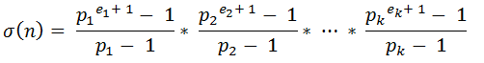
}

- Sum Of Divisors
ll divisorSum(int n) {
if (n < 2) return 0;
ll sum = 1;
for (int i = 0; n != 1; i++) {
int cnt = 1;
while (n % primes[i] == 0) n /= primes[i],cnt++;
sum *= (powl(primes[i],cnt)-1) / (primes[i]-1);
}
return sum;
}

- Sieve
const int N = 1e7; //upto 1e8
bitset<N + 5> mark; vector<ll> primes;

void sieve() {
int sq = sqrt(N);
for (int i = 4; i <= N; i += 2) mark[i] = 1;
for (int i = 3; i <= sq; i += 2) {
if (mark[i]) continue;
for (int j = i*i; j <= N; j += 2*i) mark[j] = 1;
}
for (int i = 2; i <= N; i++)
if (!mark[i]) primes.push_back(i);
}

- Linear Sieve
const int N = 1e8+5;
vector <int> spf(N+1), primes;

void LS() {
for (int i = 2; i <= N; ++i) {
if (spf[i] == 0) {
spf[i] = i; primes.push_back(i);
}
for (int j = 0; i * primes[j] <= N; ++j) {
spf[i * primes[j]] = primes[j];
if (primes[j] == spf[i]) break;
}
}
}

- Smallest Prime Factors
const ll N = 1e7 + 5;
int spf[N];

void smallest() {
for (int i = 2; i < N; i += 2) spf[i] = 2;
for (int i = 3; i < N; i += 2) {
for (int j = i; j < N; j += i * 2) {
if (spf[j] == 0) spf[j] = i;
}
}
}

vector<int> factors;
void pf(int n) {
while (n > 1) {
factors.push_back(spf[n]);
n /= spf[n];
}
}

- Pre-calculate (the NO of) divisors from 1 to N.
const int n = 1e5;
vector<int> divisors[n + 1], div(n+1, 0);
void genDivisors() {
for (int i = 1; i <= n; i++) {
for (int j = i; j <= n; j += i) {
divisors[j].push_back(i); //div[j]++;
}
}
}

- 1 to N Prime Factors
const int MX = 1e6 + 5;
vector<int> pf[MX]; // Prime Factors

void pre_cal() {
for (int p = 2; p < MX; p++) {
if (mark[p]) continue;
for (int multi = p; multi < MX; multi += p) {
pf[multi].push_back(p);
}
}
}

- nCr % M
const int MX = 1e6 + 2, MOD = 1e9 + 7;
ll fact[MX], inv[MX];

void precalc() {
fact[0] = 1;
for (int i = 1; i < MX; i++) {
fact[i] = ((fact[i-1] % MOD) * (i % MOD)) % MOD;
}
for (int i = 0; i < MX; i++) {
inv[i] = BigMod(fact[i], MOD - 2, MOD);
}
}

ll nCr(ll n, ll r) {
ll up = fact[n] % MOD; // n!
ll down = ((inv[r]) * (inv[n - r])) % MOD;
return (up * down) % MOD;
}
precalc(); // must call in main function

- Phi Function // O(sqrt(N))
int phi(int n) {
int result = n;

for (int i = 2; i * i <= n; i++) {
if (n % i == 0) {
while (n % i == 0) n /= i;
result -= result / i;
}
}

if (n > 1) result -= result / n;
return result;
}

- Ternary Search

while(hi - lo >= 3) {
int m1 = lo + (hi - lo) / 3.0;
int m2 = hi - (hi - lo) / 3.0;
}

- Phi 1 to n: O(N log log N)

void phi_1_to_n(int n) {
vector <int> phi(n + 1);

for (int i = 0; i <= n; i++) phi[i] = i;
for (int i = 2; i <= n; i++) {
if (phi[i] == i) {
for (int j = i; j <= n; j += i)
phi[j] -= phi[j] / i;
}
}
}

- divisors of an integer n in O($\sqrt[3]{n}$) time
vector <pair<int, int>> v // prime, cnt
vector <int> divisors

void getdivisors(int ind, int num) {
if (ind == v.size()) {
divisors.push_back(num);
return;
}
for (int i = 0; i <= v[ind].second; i++) {
getdivisors(ind + 1, num);
num *= v[ind].first;
}
}

- Principle of Inclusion and Exclusion - PIE
∣A∪B∪C∣ = ∣A∣+∣B∣+∣C∣ − ∣A∩B∣−∣A∩C∣−∣B∩C∣ + ∣A∩B∩C∣

ll PIE(vector <int> &v, int n, ll m) {
ll even = 0, odd = 0;
for (int mask = 1; mask < (1LL << n); mask++) {
ll tmp = m;
for (int i = 0; i < n; i++) {
if (mask & (1LL << i)) tmp /= v[i];
}
if(__builtin_popcountll(mask) & 1) odd +=tmp;
else even += tmp;
}
return odd - even;
}//O(2^n * n)

● Derangements
ll Derangements (ll n) {
if (n == 1 or n == 2) return n - 1;
ll a = 0, b = 1;
for (ll i = 3; i <= n; ++i) {
ll cur = ((i - 1) * (a + b)) % MOD;
a = b, b = cur;
}
return b;
}

- compute log a to any base b (logb a)
int log_a_to_base_b(int a, int b) {
return log2(a) / log2(b);
}
- Base conversion
log_{b2}(X) = (log_{b1}(X))/(log_{b1}(b2))

- Pair in unordered_map

struct pair_hash {
template <class T1, class T2>
size_t operator() (const pair<T1, T2> &p) const {
return hash<T1>()(p.first) ^ (hash<T2>()(p.second) << 1);
}
};

- MÖBIUS INVERSION

const int MX = 1e6 + 5;
int mu[MX], freq[MX];

void mobius(int limit) {
vector<int> primes;
vector<bool> vis(limit + 1, 0);
mu[1] = 1;
for (int i = 2; i <= limit; ++i) {
if (!vis[i]) {
primes.push_back(i);
mu[i] = -1;
}
for (int p : primes) {
if (i * p > limit) break;
vis[i * p] = 1;
if (i % p == 0) { // ⇒ square factor
mu[i * p] = 0;
break;
} else mu[i * p] = -mu[i];
}
}
}

Useful Built-in functions.
- Calculates log2(n) n != 0 in O(1) __lg(n)
- vec.resize(unique(all(vec)) – vec.begin()); or vec.erase(unique(all(vec)), vec.end());
- Counts set bits in O(1) : __builtin_popcountll(n)
- Counts the leading number of zeros of value: __builtin_clzll(x)
- Counts the trailing number of zeros of value: __builtin_ctz(x)
- Index of first set bit: __builtin_ffs(x)
- Index of the highest set bit: __lg(x)
- Converts Bitset to long long O(n) bit.to_ullong()
- returns e raised to the given power:
${e^{x}}^{}$in ld m = expl(x)
- computes natural (base e) logarithm ln(x) ld logl(x)
- log10l(x), log2l(x), sqrtl(x), powl(x), $\sqrt[3]{x}$ = cbrtl(x)
- sinl(x), cosl(x), tanl(x) // it takes and returns in radian, if you want to pass a degree, you have to convert it to radian first.
To convert to degrees
double degree = 60;
double radian = degree * PI / 180;
cout << cos(radian) << endl; // 0.5 value of cos(60 degree)

- Some STL Hacks

Fast unordered_map
unordered_map<int,int>mp;
mp.reserve(1024);
mp.max_load_factor(0.25);

- Double Comparison //EPS = 1e-9;
bool equal(double a, double b) {
if (fabs(a - b) <= EPS)
return true; else return false;
}

bool notEqual(double a, double b) {
if (fabs(a - b) > EPS)
return true; else return false;
}
bool lessThan(double a, double b) {
if (a + EPS < b)
return true; else return false;
}
bool greaterThan(double a, double b) {
if (a > b + EPS)
return true; else return false;
}
bool lessThanOrEqual(double a, double b) {
if (equal(a, b) or (lessThan(a, b)))
return true; else return false;
}
bool greaterThanOrEqual(double a, double b) {
if (equal(a, b) or greaterThan(a, b))
return true; else return false;
}

- Print all substrings
for (int i = 0; i < sz(s); i++) {
for (int j = 1; j < sz(s) - i + 1; j++) {
cout << s.substr(i, j) << endl;
}
}

Data Structure

- Prefix Sum On a 2D Array

void solve() {
for (int i = 1; i <= n; i++) {
for (int j = 1; j <= n; j++) {
v[i][j]+= v[i][j-1] + v[i-1][j] - v[i-1][j-1];
}
}

while (q--) {
int y1, x1, y2, x2;
cin >> y1 >> x1 >> y2 >> x2;
cout << v[y2][x2] - v[y1-1][x2] - v[y2][x1-1] +
v[y1-1][x1-1] << endl;
}
}

- Monotonic Queue

//Minimum value of window size k.

int a[N], n, k;
deque <int> dq;

void findMin() {
int l = 0, r = 0;

while (r < n) {
while (!dq.empty() and a[dq.back()] > a[r]) { dq.pop_back();
}
dq.push_back(r);
if (l > dq.front()) dq.pop_front();
if (r - l + 1 >= k) {
cout << a[dq.front()] << ' ';
l++;
}
r++;
}
}

- Next Greater Element

int Right[N];
stack<int> st;

for (int i = n; i >= 1; i--) {
while (!st.empty() and a[st.top()] <= a[i]) {
st.pop();
}
if (st.empty()) Right[i] = n + 1;
else Right[i] = st.top();
st.push(i);
}

- Sparse Table

const int N = 2e5 + 5;
ll tree[N][21]; int arr[N];

void build() {
for (int i = 1; i <= n; i++) tree[i][0] = arr[i];
for (int j = 1; j <= 20; j++) {
for (int i = 1; i + (1 << j) - 1 <= n; i++) {
tree[i][j] = gcd(tree[i][j-1],
tree[i+(1 << (j-1))][j-1]);
}
}
}

ll query(int lo, int hi) {
int lg = __lg(hi - lo + 1);
return gcd(tree[lo][lg],tree[hi-(1<< lg)+1][lg]);
}
Graph Theory

int dx[] = { 0, -1, 0, 1, -1, 1, -1, 1};
int dy[] = { -1, 0, 1, 0, -1, -1, 1, 1};
// L, U, R, D, LU, RU, RD, LD

- 0/1 BFS for shortest path

void solve() {
int n, e; cin >> n >> e;
vector<pair<int, int>> g[n + 1];

bool vis[n] = {0};
int dis[n], src = 1;

deque<int> dq;

dq.push_back(src);
vis[src] = 1, dis[src] = 0;

while (!dq.empty()) {
int u = dq.front(); dq.pop_front();

for (auto [v, w] : g[u]) {
if (w == 1 or vis[v]) continue;
vis[v] = 1; dis[v] = dis[node] + w;
dq.push_front(v);
}

for (auto [v, w] : g[u]) {
if (w == 0 or vis[v]) continue;
vis[v] = 1; dis[v] = dis[node] + w;
dq.push_back(v);
}
}

for (int i = 1; i <= n; i++) {
cout << i << " : " << dis[i] << endl;
}
}

- Prim's Algorithm
//Function to find the sum of weights of edges of the Minimum Spanning Tree. // O(ElogE)

int spanningTree(int V, vector<pair<int,int>> *adj){
minHeap <pair<int,int>> q;
vector <int> vis(V, 0);
q.push({0, 0}); // weight and node
int sum = 0;

while (!q.empty()) {
auto [w, u] = q.top();
q.pop();

if (vis[u] == 1) continue;
vis[u] = 1;
sum += w;

for (auto [v, adjw] : adj[u]) {
if (!vis[v]) q.push({adjw, v});
}
}

return sum;
}

- Path printing of a grid

while (!found and !q.empty()) {
auto [r, c] = q.front();
q.pop();

for (int i = 0; i < 4; i++) {
int row = r + dx[i], col = c + dy[i];
if (row >= 0 && row < n && col >= 0 && col < m && grid[row][col] != '#' && !vis[row][col]) {
if (col == c) {
if (row < r) path[row][col] = 'U';
else path[row][col] = 'D';
}
else if (row == r) {
if (col < c) path[row][col] = 'L';
else path[row][col] = 'R';
}

if (grid[row][col] == 'B') {
sr = row, sc = col;
found = 1;
}

vis[row][col] = 1;
q.push({row, col});
}
}
}

list <char> ans;

while (path[sr][sc] != 'A' and found) {
ans.push_front(path[sr][sc]);
if (path[sr][sc] == 'U') sr++;
else if (path[sr][sc] == 'D') sr--;
else if (path[sr][sc] == 'R') sc--;
else if (path[sr][sc] == 'L') sc++;
}

- Path printing of list / Dijkstra

vector<int> BFS(int n, int src, int destination, vector <pair<int, int>> *g) {
vector <int> dis(n+1, INT_MAX), parent(n+1, 0);
minHeap <pair<int,int>> pq;
parent[src] = src;
pq.push({0, src});
dis[src] = 0;

while (!pq.empty()) {
auto [w, u] = pq.top(); pq.pop();
if (dis[u] < w) continue;

for (auto [v, edgw] : g[u]) {
if (w + edgw < dis[v]) {
dis[v] = w + edgw;
parent[v] = u;
pq.push({w + edgw, v});
}
}
}

int node = destination;
vector<int> path;

while (parent[node] != node) {
path.push_back(parent[node]);
node = parent[node];
}

reverse(all(path));
path.push_back(destination);
return path;
}
- Kosaraju
vector <bool> vis;
void dfs(int v, vector <vector<int>> const& g, vector <int> &output) {
vis[v] = true;
for (auto u : g[v]) if (!vis[u]) dfs(u, g, output);
output.push_back(v);
}

void Kosaraju(vector <vector<int>> const& g, int &n, int &k) {
vector <int> order, id(n + 1, 0);
vector <ll> count(n + 1, 0);
vis.assign(n + 1, false);
for (int i = 1; i <= n; i++)
if (!vis[i]) dfs(i, g, order);

vector <vector<int>> rg(n + 1), DAG;
for (int v = 1; v <= n; v++)
for (int u : g[v]) rg[u].push_back(v);
vis.assign(n + 1, false);
reverse(order.begin(), order.end());

int root = 0;
for (auto v : order){
if(vis[v]) continue;
vector<int> cmp;
dfs(v, rg, cmp);
count[root] = sz(cmp);
for (auto u : cmp) id[u] = root;
root++;
}

DAG.assign(root + 1, {});
for (int v = 1; v <= n; v++){
for (auto u : g[v]){
if (id[v] != id[u]) DAG[id[v]].push_back(id[u]);
}
}
vector<vector<ll>>dp(root+1, vector<ll>(k+1,-1));

function <ll(int, int)> fun = [&](int u, int k){
if(k == 0) return 0LL;
if(dp[u][k] != -1) return dp[u][k];
ll x = count[u];
for(auto v : DAG[u]){
x = max(x, count[u] + fun(v, k -1));
}
return dp[u][k] = x;
};

ll ans = 0;
for(int i = 0; i < root; i++)
ans = max(ans, fun(i, k));
cout << ans << endl;
}

void solve(){
int n, m, k; cin >> n >> m >> k;
vector <vector<int>> g(n+1);
for(int i = 0; i < m; i++){
int u, v; cin >> u >> v;
g[u].push_back(v);
}

Kosaraju(g, n, k);
}

- Hierholzer’s algorithm
while(!st.empty()){ // Eulerian circuit
int u = st.top();
if(!g[u].empty()){
auto [v, i] = g[u].back();
g[u].pop_back();
if(edge[i]) continue;
edge[i] = true;
st.push(v);
} else {
path.push_back(u);
st.pop();
}
}

- DSU
struct DSU { // O(4xalpha) = Constant time
vector <int> Sz, Par;
DSU (int n) {
Sz.resize(n + 1), Par.resize(n + 1);
for (int i = 0; i <= n; i++) {
Par[i] = i, Sz[i] = 1;
}
}

int Find (int u) {
return Par[u] = Par[u] == u ? u : Find(Par[u]);
}

void Union (int u, int v) {
u = Find(u), v = Find(v);
if (u == v) return;
if(Sz[u] < Sz[v]) swap(u, v);
Par[v] = u, Sz[u] += Sz[v];
}
};

- Tarjan's Algorithm
void Bridges(int u, int p, vector <int> *g) {
vis[u] = 1; low[u] = tin[u] = ++timer;
for (int &v : g[u]) {
if (v == p) continue;
if (!vis[v]) {
Bridges(v, u, g);
low[u] = min(low[u], low[v]);
if (tin[u] < low[v]) br.push_back({u, v});
} else low[u] = min(low[u], low[v]);
}
}

void Point(int u, int p, vector <int> *g) {
int child = 0; vis[u] = 1;
tin[u] = low[u] = timer++;
for (int &v : g[u]) {
if (v == p) continue;
if (!vis[v]) {
Point(v, u, g);
low[u] = min(low[u], low[v]);
if (low[v] >= tin[u] && p != -1) mark[u] = 1;
child++;
} else low[u] = min(low[u], tin[v]);
}
if (p == -1 && child > 1) mark[u] = 1;
}

Tree
- Binary Lifting
int const N = 2e5+5;
vector <int> tree[N];
int ancestor[N][21], depth[N];

void binary_lifting(int u, int p){
if(u != 0) depth[u] = depth[p] + 1;
ancestor[u][0] = p;

for(int i = 1; i <= 20; i++){
if(ancestor[u][i-1] != -1){
ancestor[u][i] = ancestor[ancestor[u][i-1]][i-1];
} else ancestor[u][i] = -1;
}

for(auto &v : tree[u]){
if(v != p) binary_lifting(v, u);
}
}

int query(int node, int k){
if(depth[node] < k) return -1;
for(int i = 20; i >= 0; i--){
if(k & (1 << i)){
node = ancestor[node][i];
k -= (1 << i);
}
}
return node;
}

- LCA, Tree Flattening

const int N = 3e5+5, LN = __lg(N) + 1;
int level[N], dp[N][LN], in[N], out[N];
int arr[N], flat[2*N], timer, t = 1;
vector <int> tree[N];

void dfs(int u, int p) {
dp[u][0] = p;
in[u] = ++timer;
flat[timer] = arr[u];
level[u] = level[p] + 1;

for(int i = 1; i < LN; ++i)
dp[u][i] = dp[dp[u][i-1]][i-1];
for(auto v : tree[u]) {
if(v != p) dfs(v, u);
}

flat[++timer] = -arr[u];
out[u] = timer;
}

int lca(int u, int v) {
if(level[u] < level[v]) swap(u, v);
int diff = level[u] - level[v];

for(int i = 0; i < LN; ++i) {
if(diff & (1 << i)) u = dp[u][i];
}
if(u == v) return u;

for(int i = LN-1; i >= 0; --i) {
if(dp[u][i] != dp[v][i]) {
u = dp[u][i];
v = dp[v][i];
}
}
return dp[u][0];
}

- Palindrome or not
const int MX = 2e5+5;
int sbtr[MX][26];
char ch[MX];

void dfs(int u, int parent, vector <int> *tree){
sbtr[u][ch[u]-'a'] = 1;
for(auto &v : tree[u]){
if(v != parent) {
dfs(v, u, tree);
for(int i = 0; i < 26; i++){
sbtr[u][i] += sbtr[v][i];
}
}
}
}

Segment Tree

const int lim = 2e5 + 5;
int arr[lim];
ll segTree[4 * lim];

#define left (idx * 2)
#define right (idx * 2 + 1)
#define mid ((lo + hi) / 2)

void build(int idx, int lo, int hi) {
if (lo == hi) {
segTree[idx] = arr[lo];
return;
}
build(left, lo, mid), build(right, mid + 1, hi);
segTree[idx] = min(segTree[left], segTree[right]);
}

ll query(int idx, int lo, int hi, int i, int j) {
if (i > hi or j < lo) return LONG_MAX;
else if (i <= lo and hi <= j) return segTree[idx];
return min(query(left, lo, mid, i, j), query(right, mid + 1, hi, i, j));
}

void update(int idx, int lo, int hi, int i, int val) {
if (i > hi or i < lo) return;
else if (i <= lo and hi <= i) {
segTree[idx] = val;
return;
}
update(left, lo, mid, i, val), update(right, mid + 1, hi, i, val);
segTree[idx] = min(segTree[left], segTree[right]);
}

void solve() {
for (int i = 1; i <= n; i++) cin >> arr[i];
build(1, 1, n); update(1, 1, n, k, u);
query(1, 1, n, a, b)
}

- lazy Propagation
const int lim = 2e5+5;//copy #define part from above
ll input[lim];
pair <ll, ll> tree[4 * lim];

void buildTree(int idx, int lo, int hi) {
if (lo == hi) {
tree[idx].second = input[lo];
tree[idx].first = 0;
return;
}
buildTree(left, lo, mid), buildTree(right,mid+1,hi);
tree[idx].second = tree[left].second +
tree[right].second;
}

void update(int idx, int lo, int hi, int i, int j, ll val) {
if (i > hi || j < lo) return;
else if (i <= lo && hi <= j) {
tree[idx].second += (hi - lo + 1) * val;
tree[idx].first += val;
return;
}
update(left, lo, mid, i, j, val), update(right, mid + 1, hi, i, j, val);
tree[idx].second = (tree[left].second + tree[right].second) + (hi - lo + 1) * tree[idx].first;
}

ll query(int idx, int lo, int hi, int i, int j, ll carry = 0) {
if (lo > j || hi < i) return 0;
else if (i <= lo && hi <= j) {
return tree[idx].second + carry * (hi-lo+1);
}
ll leftQuery = query(left, lo, mid, i, j, carry + tree[idx].first);
ll rightQuery = query(right, mid + 1, hi, i, j, carry + tree[idx].first);
return leftQuery + rightQuery;
}

void solve() {
for (int i = 1; i <= n; i++) cin >> input[i];
buildTree(1, 1, n);update(1, 1, n, a, b, val);
query(1, 1, n, i, j)
}

Bit Manipulation

- Check Odd or Even : (x & 1) // 1 means odd
- Check if Kth bit is Set : (x & (1 << k))
- Set the Kth bit : (x | (1 << k))
- Unset the Kth bit : (x & ~(1 << k))
- Toggle the Kth bit : (x ^ (1 << k))
- Multiply or divide a number by $2^{k}$ :
  - Mul : (x << k)
  - Div : (x >> k)
- Find out X % $2^{k}$ : x & ((1 << k) - 1) // remainder

- Swap two value : swap(x, y)
  - x = x ^ y;
  - y = x ^ y;
  - x = x ^ y;
- Property: No of set bits in A = X
No of set bits in B = Y
No of set bits in (A ^ B) = Z

- Then Z is even if (X + Y) is even
Z is odd if (X + Y) is odd

- if(X == A) X = B, else X = A :- X = A ^ B ^ X
- Sum of two values:
    - A + B = (A ^ B) + 2(A & B)
    - A + B = (A | B) + (A & B)

- Is Divisible By 2^k
bool isDivisibleByPowerOf2(int n, int k) {
return (n & ((1 << k) - 1)) == 0;
}

- Generate all possible combinations up to 63
for (int mask = 0; mask < (1LL << n); mask++) {
for (int i = 0; i < n; i++) {
if (mask & (1LL << i))
sum1 += a[i];
else
sum0 += a[i];
}
res = min(res, abs(sum0 – sum1));
}
- Meet in the middle
// n <= 50, O(2^(n/2))
for (int mask = 0; mask < (1 << n / 2); mask++) {
int sum = 0;
for (int i = 0; i < n / 2; i++) {
if (mask & (1 << i)) sum += v[i];
}
ans.push_back(sum);
}

for (int mask = 0; mask < (1 << (n - (n/2))); mask++) {
int sum = 0;
for (int i = 0, j = n / 2; i < n - (n/2); i++, j++) {
if (mask & (1 << i)) sum += v[j];
}
ans.push_back(sum);
}

Dynamic Programming

- Printing LCS Using the Tabulation Method

string lcs(string a, string b) {// 1->based indexing
int n = sz(a), m = sz(b);
vector<vector<int>> dp(n+1, vector<int> (m+1,0));

for (int i = 1; i <= n; i++) {
for (int j = 1; j <= m; j++) {
if (a[i - 1] == b[j - 1]) {
dp[i][j] = 1 + dp[i - 1][j - 1];
}
else {
dp[i][j] = max(dp[i - 1][j], dp[i][j - 1]);
}
}
}

string ans = "";
int i = n, j = m, len = dp[n][m], idx = len - 1;
for (int i = 0; i < len; i++) ans += '$';
//O(n + m) at the worst case

while (i > 0 and j > 0) {
if (a[i - 1] == b[j - 1]) {
ans[idx--] = a[i - 1];
i--, j--;
}
else if (dp[i - 1][j] > dp[i][j - 1]) i--;
else j--;
}
return ans;
}

- LIS(Longest Increasing Subsequence)

int n; cin >> n;
vector <int> v;
for (int i = 0; i < n; i++) {
int in; cin >> in;
auto idx = lower_bound(all(v), in);
if (idx != v.end()) v[idx - v.begin()] = in;
else v.push_back(in);
}
cout << sz(v) << endl;

String Algorithms
- Rolling Hash
const int N = 1700000, MOD = 1e9 + 7;
const ll P[] = {97, 1000003};

ll bigMod (ll a, ll e) {
if (e == -1) e = MOD - 2;
ll ret = 1;
while (e) {
if (e & 1) ret = ret * a % MOD;
a = a * a % MOD, e >>= 1;
}
return ret;
}
int pwr[2][N], inv[2][N];

void initHash() {
for (int it = 0; it < 2; ++it) {
pwr[it][0] = inv[it][0] = 1;
ll INV_P = bigMod(P[it], -1);
for (int i = 1; i < N; ++i) {
pwr[it][i] = (ll) pwr[it][i - 1] * P[it] % MOD;
inv[it][i] = (ll) inv[it][i - 1] * INV_P % MOD;
}
}
}
//Call initHash. The functions are 0-indexed.
struct RangeHash {
vector <int> h[2], rev[2];

RangeHash (const string S, bool revFlag = 0) {
for (int it = 0; it < 2; ++it) {
h[it].resize(S.size() + 1, 0);
for (int i = 0; i < S.size(); ++i) {
h[it][i + 1] = (h[it][i] + (ll) pwr[it][i+1] * (S[i] - 'a' + 1)) % MOD;
}
if (revFlag) {
rev[it].resize(S.size() + 1, 0);
for (int i = 0; i < S.size(); ++i) {
rev[it][i + 1] = (rev[it][i] + (ll) inv[it][i + 1] * (S[i] - 'a' + 1)) % MOD;
}
}
}
}

inline ll get (int l, int r) {
if (l > r) return 0;
ll one = (ll) (h[0][r+1] - h[0][l]) * inv[0][l+1] % MOD;
ll two = (ll) (h[1][r+1] - h[1][l]) * inv[1][l+1] % MOD;
if (one < 0) one += MOD; if (two < 0) two += MOD;
return one << 31 | two;
}

inline ll getReverse (int l, int r) {
if (l > r) return 0;
ll one = (ll) (rev[0][r + 1] - rev[0][l]) * pwr[0][r + 1] % MOD;
ll two = (ll) (rev[1][r + 1] - rev[1][l]) * pwr[1][r + 1] % MOD;
if (one < 0) one += MOD; if (two < 0) two += MOD;
return one << 31 | two;
}
}; //initHash(); RangeHash hash(s), rev(s, 1); hash.get(0, 2); rev.getReverse(1, 2);

void solve() {
initHash();

string a, b;
cin >> a >> b;

RangeHash machine(a);

multiset<ll> ms;

int x = sz(b) - 1;
for (int i = 0; i + x < sz(a); i++) {
ms.insert(machine.get(i, i + x));
}

RangeHash key(b);
ll hash = key.get(0, x);
cout << ms.count(hash) << endl;
}
Hash Trick:
ll hash = 97; //a prime number
for(int i = 0; i < sz(s); i++) {
int ind = s[i] - ‘a’;
hash = hash * 29 + ind;
//You can use this hash value
}

std::hash
hash<string> myhash;
ull hash_value = myhash(“any string”);

Palindrome check using hashing

ll hf = 0, hr = 0; // forward and reverse hashes
int len = 0;
ll power = 1; // P^0 = 1

while (q--) {
int type;
cin >> type;
if (type == 1) { //append char at the back
char c;
cin >> c;
int val = c - 'a' + 1;
len++;
hf = (hf * P + val) % MOD;
hr = (hr + val * power) % MOD;
power = (power * P) % MOD;
}
else if (type == 2) {//append char at front
char c;
cin >> c;
int val = c - 'a' + 1;
len++;
hf = (hf + val * power) % MOD;
hr = (hr * P + val) % MOD;
power = (power * P) % MOD;

} else if (type == 3) { // palindrom or not
cout << (hf == hr ? "YES\n" : "NO\n");
}
}

String Class

- Converts string to ll stoll(s) // s = “454”
- Converts string to ld stold(s) // s = “3435.345”
- Converts ll to string to_string(x); //ll x =343;
- Substring Generator s.substr(1st pos, last pos);
- size_t found = str.find(c);
if (found != string::npos)
// Find next occurrence of "for"
found = str.find(c, found + 1);
if (found != string::npos)
Useful Formulas

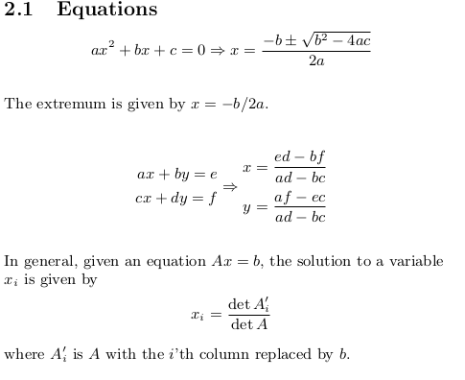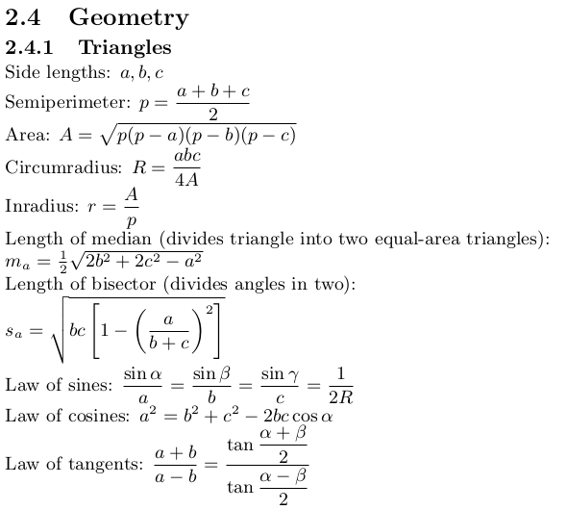

- N-th Term of an Arithmetic Progression (AP)
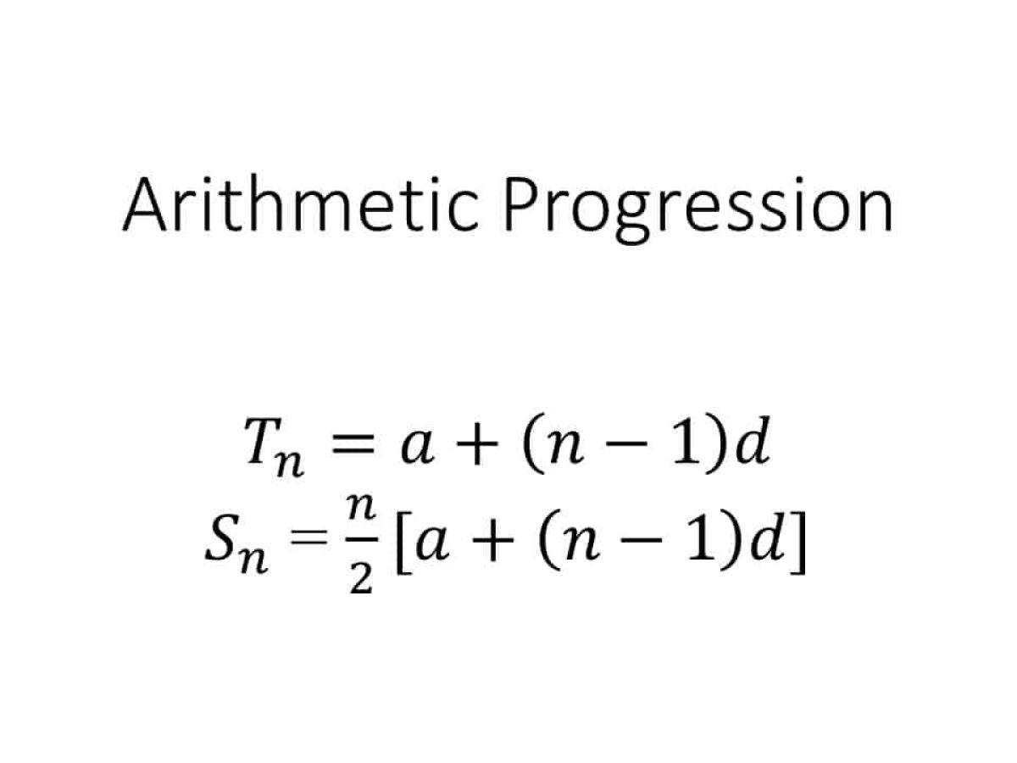
- Sum of First n Terms of (AP)

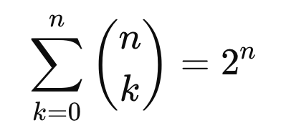
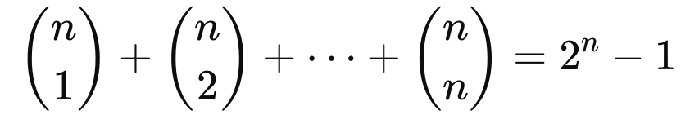
- Binomial Coefficient Sum:

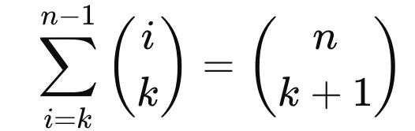
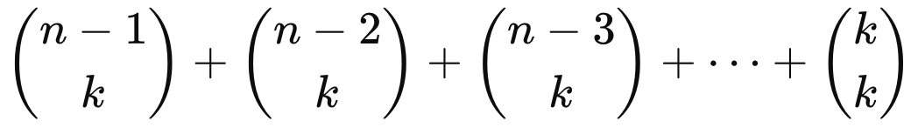
4. Pascal’s identity:

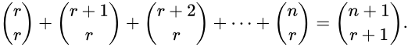
5. Hockey-stick identity:

6. Pascal’s Triangle:
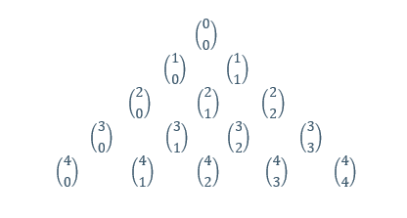
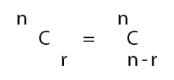
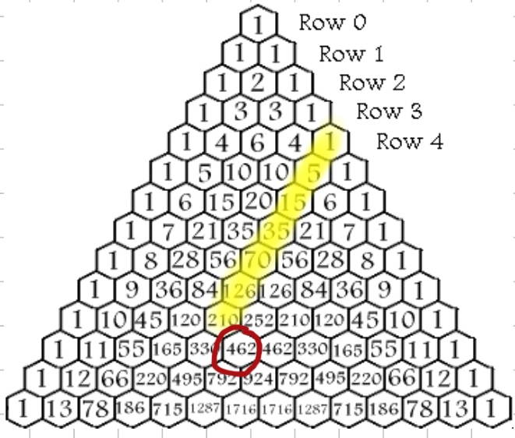

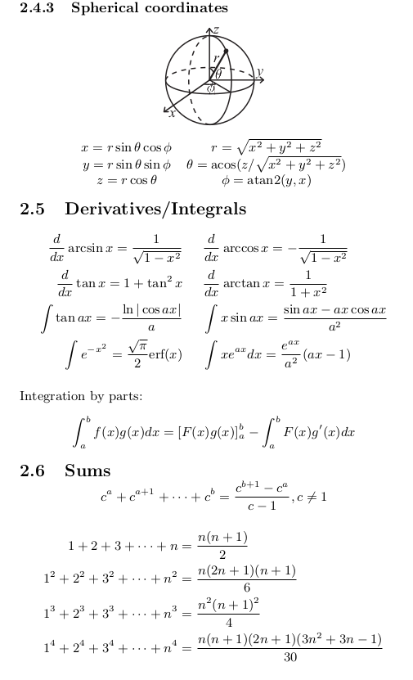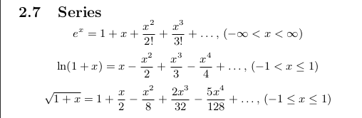

7. Cubic summation formula(triangle number)
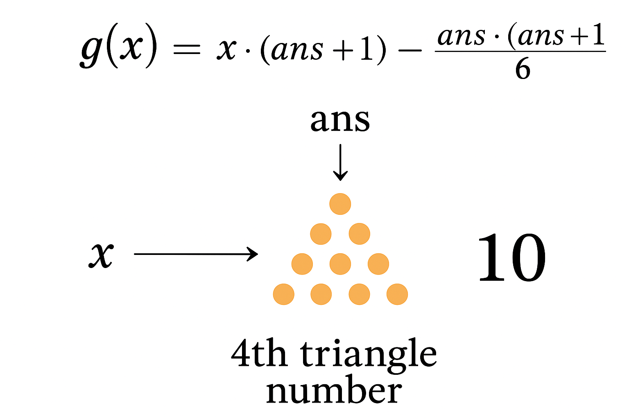
0 + 1 + 3 + 6 + 10 + 15 +. . .+ n(n + 1)/2
i’th triangle number sum :
= n * (n + 1) (n + 2) / 6;

Triangler or not :
D = (8 * n) + 1;
if(sqrtl(D) * sqrtl(D) == D);
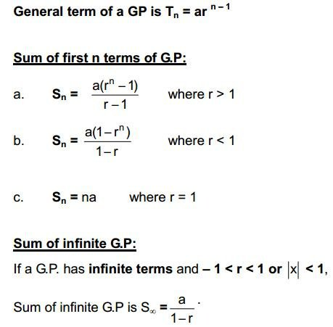

Properties of phi:
- $If gcd\left(i,n\right)= d ; where 1≤i≤n-1 then, there are phi\left(\frac{n}{d}\right)possible values of i.$
- $phi\left(p^{k}\right)=p^{k}-p^{k-1}$
- $x^{n}=x^{φ\left(m\right)+[n mod φ\left(m\right)]} mod m$ ;where n>= log₂m

Properties of mod:
- $ac = bc \left(mod m\right), then a = b mod\frac{m}{g\left(c,m\right)}$
- $mn \left(mod n\right)=0 then the smallest number m is equal to lcm(n,d)$
- $if p is prime, then {(x+y)}^{p} = x^{p}+y^{p} (mod p).$
- $ab (mod ac) = a (b mod c)$
Properties of GCD:
- gcd(a, 0) = |a|
- gcd(a, b) = gcd(a-b, b) // a > b
- gcd(a, b) = gcd(b, a % b)
- ax + by = gcd(a, b)// a,b > 0 Bezout’s identity
- ax + by = c // gcd(a, b) | c

Properties of Digitsum:
  - $DigitSum(x+y) = DigitSum(DigitSum(x) + DigitSum(y))$
  - $DigitSum(x-y) = DigitSum(DigitSum(x) - DigitSum(y))$
  - $DigitSum(x*y)=DigitSum(DigitSum(x)*y))$
  - $DigitSum(x*y)=DigitSum(x*DigitSum(y))$
  - $DigitSum(x*y)=DigitSum(DigitSum(x)*DigitSum(y))$
  - $DigitSum\left(x^{y}\right)=DigitSum\left({DigitSum\left(x\right)}^{y}\right)$
  - $DigitSum(x^{y}) = {DigitSum(x}^{y\%ε}) where {DigitSum(x}^{ε})$=1

Properties of FLOOR CEIL:
- $⌈\frac{n}{m}⌉=⌊\frac{n+m-1}{m}⌋=⌊\frac{n-1}{m}⌋+1$
- $⌊\frac{n}{m}⌋=⌈\frac{n+m-1}{m}⌉=⌈\frac{n-1}{m}⌉+1$
- $\sum_{k=1}^{n-1}{}⌊\frac{kn}{m}⌋=\frac{\left(m-1\right)\left(n-1\right)+gcdgcd \left(m,n\right) -1}{2}$

Bit Manipulation Macros
#define least_one_pos(x) __builtin_ffs(x)
#define leading_zeros(x) __builtin_clz(x)
#define tailing_zeros(x) __builtin_ctz(x)
#define num_of_one(x) __builtin_popcount(x)
#define msb(x) 32-leading_zeros(x)

Important Series and Properties
- $\sum_{n≥0}{}a^{n}z^{n}=\frac{1}{1-az}$
- $\sum_{n≥0}{}\left(\frac{m}{n}\right)z^{n}={\left(1+z\right)}^{m} \left(m∈Z\right)$
- $\sum_{n≥0}{}\left(\frac{m+n-1}{n}\right)z^{n}=\frac{1}{{(1-z)}^{m}} \left(m∈Z\right)$
- $\sum_{n≥0}{}\left(\frac{m+n}{n}\right)z^{n}=\frac{1}{{\left(1-z\right)}^{m+1}} \left(m∈Z\right)$
- $\sum_{n≥0}{}\left(\frac{n}{m}\right)z^{n}=\frac{z^{m}}{{(1-z)}^{m+1}} \left(m∈N\right)$
- $\sum_{n≥0}{}\left(\frac{p+n}{m}\right)z^{n}=\frac{z^{m-p}}{{(1-z)}^{m+1}}$
- $\sum_{n≥0}{}\frac{z^{n}}{n!}=e^{z}$
- $\sum_{n≥0}{}{-1}^{n-1}\frac{z^{n}}{n}=log⁡(1+z)$
- Vandermonde $\left(\frac{x+y}{n}\right)=\sum_{k=0}^{n}{}\left(\frac{x}{k}\right)\left(\frac{y}{n-k}\right)$
- $\sum_{m=0}^{n}{}\left(\frac{m}{k}\right)=\sum_{k=0}^{n}{}\left(\frac{i}{k}\right)=\left(\frac{n+1}{k+1}\right)$
- $\sum_{k=0}^{n}{}\left(\frac{n}{k}\right)=2^{n}$
- $\sum_{k=0}^{m}{}\left(\frac{n+k}{k}\right)=\left(\frac{m+n+1}{m}\right)$
- $\sum_{k=0}^{n}{}{\left(\frac{n}{k}\right)}^{2}= \left(\frac{2n}{n}\right)$
- $\sum_{k=1}^{n}{}k\left(\frac{n}{k}\right)= {n2}^{n-1}$
- $a+ar+ar^{2}+..+{ar}^{n}=\frac{a(1-r^{n})}{1-r}$
- $sum of xor of all possible subarray=(or of all elements* 2^{n-1}$
- $sum of sum of all possible subarray=(sum of all elements* 2^{n-1}$
- De Araangement Recursive Formula - $D_{n}=(n-1)(D_{n-1}+D_{n-2}$)
- Catalan Number -
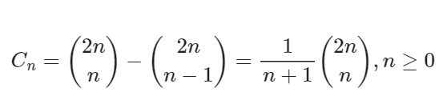
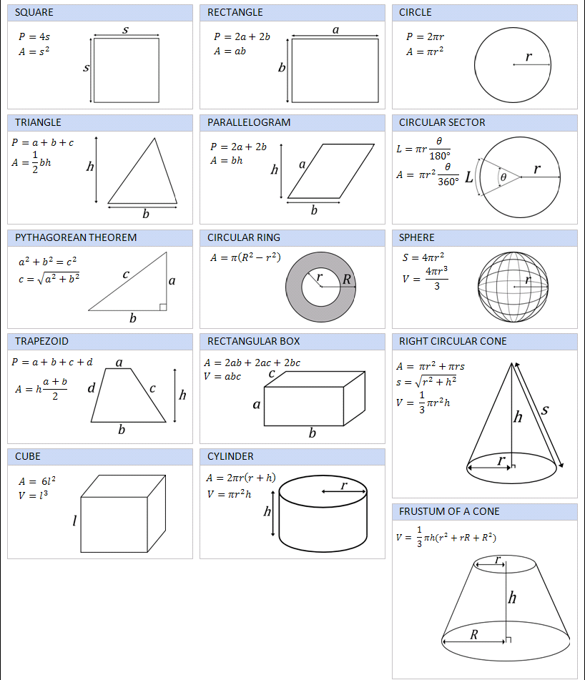
Geometry using std::complex
Defining our point class
We can define our point class by typing typedef complex<double> point; at the start of our program. To access our x- and y-coordinates, we can macro the real() and imag() functions by using #define. Of course, don't forget to #include <complex> before anything.

#include <iostream>
#include <complex>
using namespace std;

// define x, y as real(), imag()
typedef complex<double> point;
#define x real()
#define y imag()

// sample program
int main() {
point a = 2;
point b(3, 7);
cout << a << ' ' << b << endl; //(2,0)(3,7)
cout << a + b << endl; // (5, 7)
}
Oh goodie! We can use std:cout for debugging! We can also add points as vectors without having to define operator+. Nifty. We can add points, subtract points, and do scalar multiplication without defining any operator. Very nifty indeed.

Example
point a(3, 2), b(2, -7);

// vector addition and subtraction
cout << a + b << endl; // (5,-5)
cout << a - b << endl; // (1,9)

// scalar multiplication
cout << 3.0 * a << endl; // (9,6)
cout << a / 5.0 << endl; // (0.6,0.4)

Functions using std::complex
What else can we do with complex numbers? There's a lot that's easy to code.
- Vector addition: a + b
- Scalar multiplication: r * a
- Dot product: (conj(a) * b).x
- Cross product: (conj(a) * b).y
notice: conj(a) * b = (ax*bx + ay*by) + i (ax*by — ay*bx)
- Squared distance: norm(a - b)
- Euclidean distance: abs(a - b)
- Angle of elevation: arg(b - a)
- Slope of line (a, b): tan(arg(b-a))
- Polar to cartesian: polar(r, theta)
- Cartesian to polar: point(abs(p), arg(p))
- Rotation about the origin: a * polar(1.0, theta)
- Rotation about pivot p: (a-p) * polar(1.0, theta) + p
- Angle ABC: abs(remainder(arg(a-b) - arg(c-b), 2.0 * M_PI))
remainder normalizes the angle to be between [-PI, PI]. Thus, we can get the positive non-reflex angle by taking its abs value.
- Project p onto vector v: v * dot(p, v) / norm(v);
- Project p onto line (a, b): a + (b - a) * dot(p - a, b - a) / norm(b - a)
- Reflect p across line (a, b): a + conj((p - a) / (b - a)) * (b - a)
- Intersection of line (a, b) and (p, q):

point intersection(point a, point b, point p, point q) {
double c1 = cross(p - a, b - a), c2 = cross(q - a, b - a);
return (c1 * q - c2 * p) / (c1 - c2); // undefined if parallel
}
Drawbacks
Using std::complex is very advantageous, but it has one disadvantage: you can't use std::cin or scanf. Also, if we macro x and y, we can't use them as variables.

typedef pair<int, int> pt;

// Area of Triangle (Shoelace)
double triangle_area(double x1, double y1, double x2, double y2, double x3, double y3) {
return abs(x1*(y2 - y3) + x2*(y3 - y1) + x3*(y1 - y2)) / 2.0;
}

// Orientation
string orientation(int x1, int y1, int x2, int y2, int x3, int y3) {
int val = (y2 - y1)*(x3 - x2) - (y3 - y2)*(x2 - x1);
if (val == 0) return "Collinear";
return (val > 0) ? "Clockwise" : "Counter-clockwise";
}

// Distance Between Two Points
double distance(int x1, int y1, int x2, int y2) {
return sqrt((x2 - x1)*(x2 - x1) + (y2 - y1)*(y2 - y1));
}

// Angle Between Two Vectors (in degrees)
double angle_between_vectors(double ax, double ay, double bx, double by) {
double dot = ax * bx + ay * by;
double magA = sqrt(ax * ax + ay * ay);
double magB = sqrt(bx * bx + by * by);
return acos(dot / (magA * magB)) * 180.0 / M_PI;
}

// Convex Hull Helper
int cross(const pt &O, const pt &A, const pt &B) {
return (A.first - O.first) * (B.second - O.second) -
(A.second - O.second) * (B.first - O.first);
}

vector <pt> convex_hull(vector<pt> P) {
int n = P.size(), k = 0;
if (n <= 3) return P;

sort(P.begin(), P.end());
vector<pt> H(2 * n);

for (int i = 0; i < n; ++i) {
while (k >= 2 && cross(H[k-2], H[k-1], P[i]) <= 0) k--;
H[k++] = P[i];
}
for (int i = n - 2, t = k; i >= 0; --i) {
while (k > t && cross(H[k-2], H[k-1], P[i]) <= 0) k--;
H[k++] = P[i];
}

H.resize(k - 1);
return H;
}

int main() {
cout << fixed << setprecision(2);

// Triangle Area Example
cout << "Area of triangle: " << triangle_area(0, 0, 4, 0, 0, 3) << "\n";

// Orientation Example
cout << "Orientation: " << orientation(0, 0, 4, 4, 1, 2) << "\n";

// Distance Example
cout << "Distance: " << distance(1, 2, 4, 6) << "\n";

// Angle Example
cout << "Angle between vectors: " << angle_between_vectors(1, 0, 0, 1) << " degrees\n";

// Convex Hull Example
vector<pt> points = {{0, 3}, {2, 2}, {1, 1}, {2, 1}, {3, 0}, {0, 0}, {3, 3}};
vector<pt> hull = convex_hull(points);

cout << "Convex Hull Points: ";
for (auto &[x, y] : hull)
cout << "(" << x << ", " << y << ") ";
cout << endl;

return 0;
}

int daysInMonth[] = {31, 28/29, 31, 30, 31, 30, 31, 31, 30, 31, 30, 31};

bool isLeapYear(int year) {
return (year % 4 == 0 && year % 100 != 0) || (year % 400 == 0);
}

- Leap Year in a given range

ll LeapYearInRange(ll r, ll l) {
l--;
ll R = r / 4 - r / 100 + r / 400;
ll L = l / 4 - l / 100 + l / 400;
return R - L;
}

A Few Important Notes:

- A number N has $\sqrt{N}$ perfect square numbers.
- Only a Perfect Square number has an odd number of divisors.
- Harmonic Series generates a maximum of 2*$\sqrt{N}$ distinct values.
d = $\frac{N}{i}$, next = $\frac{N}{d}$
- A number N has a maximum $log2(N)$ prime divisors.
- The number of divisors of N is : $\sqrt[3]{N}$
- Prime gape: log2($N^{2}$)

Stress testing a bash script

#!/usr/bin/bash
# To color the output text in different colors.
green=$(tput setaf 71);
red=$(tput setaf 1);
blue=$(tput setaf 32);
orange=$(tput setaf 178);
bold=$(tput bold);
reset=$(tput sgr0);

echo "Compiling Codes"

g++ -std=gnu++20 -O2 -DLOCAL -Wall -o test_gen test_gen.cpp
g++ -std=gnu++20 -O2 -DLOCAL -Wall -o sol sol.cpp
g++ -std=gnu++20 -O2 -DLOCAL -Wall -o brute brute.cpp

for ((i = 1; ; i++)); do
./test_gen > input.txt
if diff -w <(./sol < input.txt) <(./brute < input.txt); then
echo "${orange} test_case # $i: ${bold}${green} Accepted ${reset}"
else
echo "${orange} test_case # $i: ${bold}${red} Wrong Answer ${reset}"
echo "${blue} Input: ${reset}"
cat input.txt
echo ""
break
fi
done

- __int128 //operator overloading

istream &operator >> (istream &is, __int128 &v) {
string s; is >> s; v = 0;
for(auto &it : s)
if(isdigit(it)) v = v*10 + it - '0';
if(s[0] == '-') v *= -1;
return is;
}

ostream &operator << (ostream &os, const __int128 &v) {
if(v == 0) return (os << "0");
__int128 num = v;
if(v < 0) os << '-', num = -num;
string s;
for(;num > 0; num /= 10)
s.push_back((char)(num % 10) + '0');
reverse(all(s));
return (os << s);
}
void solve() {
__int128 a; cin >> a;
__int128 b = a + a;
cout << b << endl;
}
* Do something instead of nothing and stay organized
* WRITE STUFF DOWN
* DON'T GET STUCK ON ONE APPROACH

Rewrite your solution from the start or let a teammate do it.

/* Final check before submit:

1. Array size or integer overflow, like an uninitialized 0 index.
2. Think twice, code once. Check all possible counter test cases.
3. Be careful about corner cases! n=1? k=1? Something about 0?
4. Avoid stupid mistakes!
5. If you got WA, then remember that you are missing something common.
*** Be confident!!! Who knows? may be your one step back to AC ***
4. minus mod ans = (ans – k + mod) % mod;
5. Is your output format correct? (including whitespace)
*/

Wrong Answer:

1. corner case! n=1? k=1? Something about 0?
2. Check code (avoid stupid mistakes)
3. Read the statement again (if there are any missing points???)
4. Check the idea (check all possible counter test cases again!!!)
5. Be calm, don't panic! (*** This problem is not going to decide your future***)
6. Don't waste too much time. Move to the next problem

Runtime error:

Have you tested all corner cases locally?
Any uninitialized variables?
Are you reading or writing outside the range of any vector?
Any assertions that might fail?
Any possible division by 0? (mod 0, for example)
Any possible infinite recursion?
Invalidated pointers or iterators?
Are you using too much memory?
Debug with resubmits (e.g., remapped signals, see Various)

Time limit exceeded:

Do you have any possible infinite loops?
What is the complexity of your algorithm?
Are you copying a lot of unnecessary data? (References)
How big is the input and output? (consider scanf)
Avoid vectors, maps. (use arrays/unordered_map)
What do your teammates think about your algorithm?

Memory limit exceeded:

What is the maximum amount of memory your algorithm should need?
Are you clearing all data structures between test cases?

